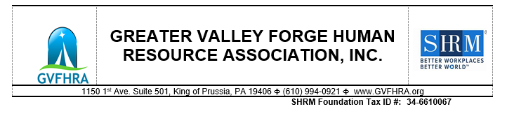
Greater Valley Forge Human Resource Association (GVFHRA)

An affiliate of SHRM Presents 2022 GVFHRA Annual Silent Auction & Holiday Event
Tuesday, December 13, 2022

Donation Request Form

Our Annual Silent Auction is fast approaching and we’re so excited to be able to bring our members and friends together again on Tuesday, December 13, 2022 to celebrate the holidays and contribute to our community!

Each year, our members are committed to helping individuals and families in our area. GVFHRA is proud to support two well deserving organizations. ALL proceeds from our 2022 Silent Auction will benefit the following 501(c)(3) non-profit organizations:

Integrate for Good – non-profit organization that empowers transition-age youth and adults with
disabilities, the families and agencies that support them, school districts, nonprofit organizations and for-profit businesses to capitalize on the strengths and abilities of all people through social capital building, civic engagement and community connection. The mission of Integrate for Good is to create opportunities for people of all abilities to contribute their talent through inclusive volunteerism, community leadership, and competitive employment.
www.integrateforgood.org. 501(c)(3) non-profit organization #: 83-3075186

The Society for Human Resource Management (SHRM) Foundation – Conducts workplace research
and awards education and certification scholarships to professional and student SHRM members. www.shrm.org/foundation. 501(c) 3 non-profit organization #: 34-6610067

We are looking for donations for our Silent Auction. We welcome donations from organizations or individuals. Please complete the form below if you or your organization would like to make a donation (product, gift basket, cash, services, workshops, etc.). Thank you for your consideration!

Donor Name (Contact Name):_________________________________________________________

Organization Name (If Applicable):_____________________________________________________

Mailing Address:____________________________________________________________________

Email Address:______________________________________________________________________

Telephone Number:_________________________________________________________________

Describe the item you are donating (please be as descriptive as possible):
__________________________________________________________________________________

Approximate value of your donation: $_________

Completed forms can be sent to Kiley Alberts at kiley.alberts@tridentcare.com or mailed along with donations to 361 E. 6th St., Lansdale, PA 19446. If you are unable to mail your donation or have any questions, please contact Kiley at 610-457-1549.

