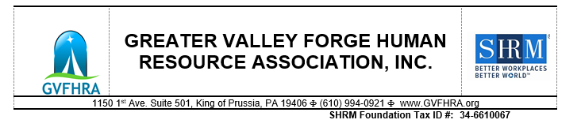
Greater Valley Forge Human Resource Association (GVFHRA)

September 25, 2022

Dear Community Partner,

We hope this letter finds you well. Our Annual Silent Auction and Holiday Networking event is fast approaching and we’re so excited to be able to bring our members and friends back together again on Tuesday, December 13, 2022 at 5:30pm to celebrate the holidays and contribute to our community!

At last year’s event, we raised almost $4,000 from local companies! We are asking for your help to make this year’s Silent Auction another successful event.

Each year, our members are committed to helping individuals and families in our immediate area. GVFHRA is proud to support two (2) well deserving organizations. ALL proceeds from our 2022 Silent Auction will benefit the following 501(c)(3) non-profit organizations:

Integrate for Good – non-profit organization that empowers transition-age youth and adults with
disabilities, the families and agencies that support them, school districts, nonprofit organizations and for-profit businesses to capitalize on the strengths and abilities of all people through social capital building, civic engagement and community connection. The mission of Integrate for Good is to create opportunities for people of all abilities to contribute their talent through inclusive volunteerism, community leadership, and competitive employment.
www.integrateforgood.org. 501(c)(3) non-profit organization #: 83-3075186

The Society for Human Resource Management (SHRM) Foundation – Conducts workplace research
and awards education and certification scholarships to professional and student SHRM members.
www.shrm.org/foundation. 501(c) 3 non-profit organization #: 34-6610067

Event Location: Crowne Plaza Hotel, 260 Mall Blvd, King of Prussia, PA 19406

Donation request: Gift Cards and Product Donations
Donation Submission: We wish to receive all donations no later than December 6, 2022. Completed forms can be sent to Kiley Alberts at kiley.alberts@tridentcare.com or mailed along with donations to 119 361 E. 6th St., Lansdale, PA 19446. If you are unable to mail your donation or have any questions, please contact Kiley at 610-457-1549.

About Greater Valley Forge HR Association: GVFHRA is a non-profit, individual membership association for human resource management professionals in the Montgomery and surrounding counties of Pennsylvania. GVFHRA is a local chapter of the national Society for Human Resource Management (SHRM).

On behalf of the entire Greater Valley Forge HR Association Board of Directors, I want to thank you for your time in consideration of donating to this great cause.

Sincerely,
Kiley Alberts, Special Projects Board Chairperson

